Homework Summary

Student ID | B812110004 | Student Name | 葉芸茜
Estimated Time | __15___ hours
Time Log | Time spent in writing program  - From 22 : 00 to 01 : 00  - From 10 : 00 to 12 : 30  - From 13 : 30 to 18 : 30  - From 19 : 00 to 24 : 00  Time spent in writing document  - From 23 : 30 to 23 : 40
Actual Time | __15.83__ hours
Difference between Estimated time and Actual Time | __0.83__ hours (|Estimated Time – Actual Time|)  __5.53__ % (|Estimated Time – Actual Time|/ Estimated Time)
Difficulty of the homework | 單元測試覆蓋率以及讓文字移動的部分，尤其是讓文字移動的部分最後還是沒能讓她很完美，現在變成只能移動一次，之後橘色點點會因為座標錯位而無法再次移動，這個部分會在未來努力繼續改進，我很抱歉。  檔案架構  MyDrawing/ (12 class, 65 method)  ├── Adapter/  │ ├── GraphicsAdapter.cs (1 class, 7 method)  │ └── IGraphics.cs (1 class, 6 method)  ├── Factories/  │ └── ShapeFactory.cs (1 class, 1 method)  ├── Shapes/  │ ├── BaseShape.cs (5 class, 17 method)  │ └── IShape.cs (1 class, 3 method)  ├── States/  │ └── DrawingState.cs (1 class, 7 method)  │ └── IDrawingState.cs (1 class, 4 method)  │ └── SelectionState.cs (1 class, 8 method)  ├── MyDrawingModel.cs (1 class, 6 method)  ├── MyDrawingPresenter.cs (1 class, 6 method)  └── MyDrawingView.cs  Test (9 class, 65 method)  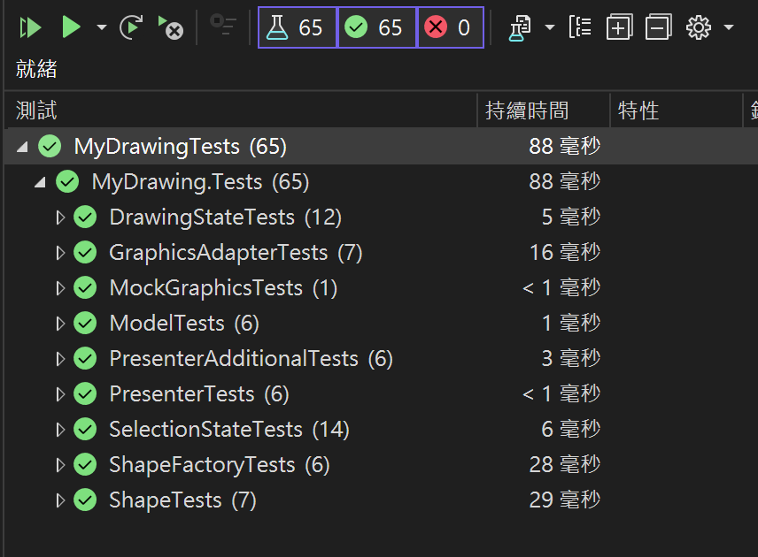
Other Issues

